Version 3
Microsoft Excel Add-In
User Manual

by Edwin H. B. Tam

Copyright © 1995-2001
ALL RIGHTS RESERVED

Notice to Users
This manual should not be construed as any representation or warranty with respect to the software named herein. Occasionally changes or variations exist in the software that are not reflected in the manual. Generally, if such changes or variations are known to exist and affect the product significantly, a release note or README file will accompany the software. In that event, please read the release note or README file before using the product.

Trademarks
Microsoft, Microsoft Excel, Microsoft Office, Microsoft Windows, and Windows NT are either registered trademarks or trademarks of Microsoft Corporation in the United States and/or other countries.
Apple, Macintosh, Power Macintosh and MacOS are either registered trademarks or trademarks of Apple Corporation in the United States and/or other countries.

Copyright
©1995-2001 Edwin H. B. Tam. All rights reserved.
All parts of Edwin’s Power Tools and its documentation, including this document, are original work of Edwin H. B. Tam. No part of these may be modified, adapted, or translated into a language or computer language, in any form by any means, electronic, mechanical, magnetic, optical, chemical, manual or otherwise, without the express written consent of the author.

CONTENTs
1. Introduction 7
1.1 What is ©Edwin's Power Tools? 7
1.2 What’s new in version 3? 7
1.3 What do I need to run Edwin's Power Tools? 7
1.4 How to reach the author 8
1.5 Purchasing Information 8
1.6 Installation 10
1.7 Inputting Registration Information 11
1.8 Unregistering & Distributing EPT 12
1.9 Removing EPT 12
2. EPT Menus, Shortcut Menus and Toolbar 13
2.1 EPT Menu 13
2.2 EPT Shortcut Menus 13
2.3 The EPT Toolbar 13
3. EPT 3D Formatting Tools 14
3.1 Basic 3D formatting commands 14
3.2 Adhesive formatting commands 14
3.3 Advanced 3D Formatting Filters 17
4. EPT 2D Formatting Tools 18
4.1 EPT Power Shader 18
5. EPT Special Selections 19
6. EPT Word Play 20
6.1 EPT Split-Up Words Wizard 20
6.2 EPT Combine Words 23
6.3 EPT Extract Initials 24
6.4 EPT Change Case 25
6.5 EPT Power Append 26
6.6 EPT Word Count 27
6.7 Randomize Order 28
6.8 EPT Random Numbers 28
6.9 Units Conversion 29
6.10 Matrix Transform 31
6.11 Negative Reposition 32
6.12 EPT Super Number->Text 33
7. EPT Killers 36
7.1 Remove Irregular Spacing 36
7.2 Remove All Space 36
7.3 EPT Duplicated Rows Killer 37
7.4 Kill Empty Sheets 39
7.5 Hyperlinks Killer 39
8. EPT Workbooks Management 40
8.1 Revert to Saved 41
8.2 EPT Navigator 41
8.3 EPT Sheets Sorter 41
8.4 EPT Zoom Control 45
8.5 EPT Duplicate Sheets 45
8.6 Print Multiple Sheets 46
8.6 Toggle Window Options 47
9. EPT Global Assignment 48
9.1 Global Assign Page Setup 48
10. EPT (Perpetual) Calendar 49
11. Miscellaneous Tools 50
11.1 Copy Column Widths 50
11.2 Copy Row Heights 50
11.3 Export Chart As Graphic 51
12. EPT Help 52
12.1 EPT On-Line Help 52
12.2 EPT User Manual 52
12.3 EPT Worksheet Function Reference 52
12.4 EPT Web Site 52
12.5 EPT On-Line Version Check * 52
13. Frequent Asked Questions 53

1. Introduction

1.1 What is ©Edwin's Power Tools?

Edwin's Power Tools (EPT) is a set of Excel add-ins, which adds useful functions to Microsoft Excel 2002, 2000 and 97 for Windows, as well as Excel 2001 and Excel 98 for Power Macintosh.

At the time when I’m writing this document, EPT 3 is probably the most sophisticated general-purpose Excel shareware add-in, which supports the most number of versions of Microsoft Excel.

1.2 What’s new in version 3?

EPT 3 is specially designed to run on all Excel 2002, 2000 & Excel 97 for Windows as well as Excel 2001 & Excel 98 for Mac. It is a very seriously designed product which emphasizes compatibility in nowadays' highly mixed offices, in which different versions of Excels are being run on different systems and users need to switch platforms frequently.

There are 2 different versions of EPT 3 : one for Windows and one for Macintosh.

All versions of EPT (for Windows and for Mac) have the same look and feel. Functions and interfaces are higher consistent.

In EPT 3, the registration system has again been strengthened. It is now even more bullet proof. To unlock the full power of EPT, just input your UserName, Address, and your unique Serial Number. You’ll be given these when you’ve registered.

1.3 What do I need to run Edwin's Power Tools?

Edwin's Power Tools 3 is fully compatible with the following versions of Excel:
- Excel 2002 (Excel 10) for Windows
- Excel 2001 for Power Macintosh
- Excel 2000 for Windows
- Excel 97 for Windows
- Excel 98 for Power Macintosh

Users of older versions of Excel can use EPT version 2.5, which is compatible with :
- Excel 2000 for Windows
- Excel 97 for Windows
- Excel 98 for Power Macintosh
- Excel 95 for Windows
- Excel 5 for Macintosh and Power Macintosh

1.4 How to reach the author

The official e-mail support address is : eptools@netvigator.com

This is also the address for technical support, comments, and bug reports.

Official EPT Home Page :

http://users.vol.net/edwintam/EPT.HTM

The author’s EPT web site is where you can always get the latest information about EPT, and download the newest versions of EPT.

You may also contact the author by post :

Edwin H. B. Tam
GPO Box 12886
Central
Hong Kong

1.5 Purchasing Information

“Edwin’s Power Tools” is freely distributed as a shareware. You are permitted to evaluate it for 30 days before discarding it, or purchasing a license.

Licensing -

You must purchase one license for each user who uses EPT. With a single-user license, a registered user can use EPT on more than one computer and on more than one version of Excel. (In case you upgrade to a newer version of Excel, you don't need to pay again.) But it is important to note that if EPT is being used by two persons, two single-user licenses will be required.

Licenses can be purchased with the enclosed Register EPT program OR by using a page on the World Wide Web. Payment may be made by cash, check, VISA, MasterCard, American Express or First Virtual.

Pricing -

Current pricing is $40 for a multi-platform single-user license, which goes down to $10 as the number of required licenses increases.

Purchasing a registration on the World Wide Web -

- Go to the web page at http://order.kagi.com/?R4
- Enter name, address and e-mail details (required) into the fields provided.
- If you require more than one license of Edwin’s Power Tools, specify in the area provided.
- Follow the rest of the instructions on the Web page.

Purchasing a registration using the register program -

- Start the Register EPT application.
- Enter name, address and e-mail details (required) into the fields provided.
- Specify how many licenses are required.
- Enter payment details in the area provided.
- Save, copy or print out the information, and forward to Kagi (as detailed below) for processing.

If you are sending the purchase via e-mail :
- Click Copy to copy the order, and paste into an e-mail message.
- Send to sales@kagi.com.

If you are sending the purchase via mail :
- Click Print to print the order, or Save to save to a file for printing later.
- Send to Kagi, 1442-A Walnut Street #392-R4, Berkeley, California, 94709-1405, USA.

If you are sending the purchase via fax :
- Click Print to print the order, or Save to save to a file for printing later.
- Fax to (US) 510 652-6589.

1.6 Installation

You can put the EPT files anywhere on your hard disk. But you're recommended to put the files into a new folder and not to be mixed up with other files on your disk.

To install Edwin's Power Tools --

- If you have a previous version of EPT on your hard disk, please delete ALL the old EPT files first.
- Place all the EPT files onto your hard disk. (You can create a new folder for storing the files if you want, e.g. a new folder called "Edwin's Power Tools" on the desktop.)
- Run Microsoft Excel.
- From the Tools menu, choose Add-Ins.
- Check the "Edwin's Power Tools" checkbox.

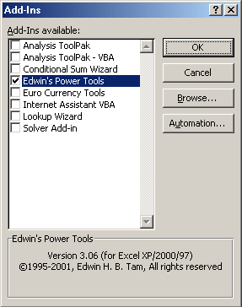

- Click OK.

If you could not find the checkbox, use the "Browse..." button to locate the appropriate EPT initialization file for your platform :

Microsoft Windows
Excel 2002, Excel 2000 and  Excel 97 for Windows | EPTOOLS.XLA

Apple Macintosh
Excel 2001 and Excel 98 for PowerMac | Edwin’s Power Tools

1.6.1 Additional Information for Mac Users

If possible, you are highly recommended to assign more memory to Microsoft Excel before using EPT. This speeds up Excel's overall operation and gives more responsive results. (About 2MB more memory than normal is recommended.)

1.7 Inputting Registration Information
(to unlock full functionality)

After installing and loading EPT in Microsoft Excel, from the EPT menu, choose “About EPT”. Then click onto the “Input Serial #” command button. Input your UserName, Address, and unique Serial Number exactly as shown in the registration confirmation, including any upper & lower cases and line feeds.

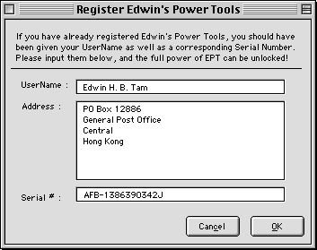

Do not try to register EPT on a server. If you installed and registered EPT on the server, and have client machines trying to access that same copy of EPT, EPT won’t function in its registered state. There are machanisms within EPT to identify such situation and this won’t be allowed.

1.8 Unregistering & Distributing EPT

Although EPT is a shareware and you're free to distribute it to your friends for evaluation, you must not distribute a REGISTERED copy of EPT. If your EPT is a registered one, before distributing it, you MUST unregister it first. To unregister EPT...

- Run "About EPT..."
- On the "About EPT" Dialog Box, click onto the "unregister" button. Answer "Yes" when you're asked to confirm.

After "unregister", EPT would be restored to its DEMO state. You can re-input your registration information afterwards.

Basically, EPT users can always conveniently download the latest versions of EPT from the official EPT web site. Please refer to Section 1.4, “How to reach the author”, of this manual.

If you distributed a registered copy of EPT, the copy won’t function on other machines.

1.9 Removing EPT

After installing EPT, if you decided to permanently remove (or uninstall) EPT from your computer, do the following steps:

- Quit Microsoft Excel.
- Completely delete ALL EPT files from your hard disk.
- Start Microsoft Excel
- From the “Tools” menu, choose “Add-Ins...”
- Locate the item “Edwin’s Power Tools”, and click once onto the checkbox.
- When a message box pops up asking you whether you want to delete the EPT file from the list, answer Yes.

(If you could not locate the item “Edwin’s Power Tools in step 5, ignore both step 5 and step 6.)

2. EPT Menus, Shortcut Menus and Toolbar

2.1 EPT Menu

You can access all the EPT functions through the EPT menu. You can find the EPT menu on the top of the screen, which is a menu item named “EPT”.

On the EPT menu, EPT functions are systematically organized. Related functions were grouped under sub-menus.

2.2 EPT Shortcut Menus

EPT provides you with enhanced shortcut menus. Whenever you want to access EPT’s functions, just right-click (or Ctrl + mouse click on the Mac) on the place you want the function to be applied, and you’ll be shown a list of EPT functions applicable to the position you clicked. (Different EPT functions would be available when you click on different positions on the screen. Only the applicable ones would be shown.)

2.3 The EPT Toolbar

EPT provides you with a toolbar for quick access to some frequently used EPT functions.

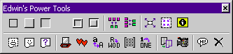
The EPT toolbar is unique compared with all toolbars in all Excel add-ins. It has the ability to “remember” its location, size and visibility before EPT is being unloaded and restore its previous position, size and visibility the next time EPT is loaded. This makes EPT more like a “real” Excel built-in component. (This feature is available in both EPT for Windows and for Mac.)

3. EPT 3D Formatting Tools

EPT provides a set of handy 3D cells formatting tools for quick formatting of tables with fancy 3D effects.

The 3D formatting tools can basically be classified into 3 categories :
- Basic 3D formatting commands
- Adhesive formatting commands
- Advanced 3D formatting filters

With these 3 types of simple commands, you have all you need to apply whatever 3D effects possible onto your Excel spreadsheet!

3.1 Basic 3D formatting commands

These include :

Make platform | Builds a “platform” on the current selection area(s) (, for application of further 3D effects).
Go In | Apply a “Depressed” effect to the current selection area(s).
Come Out | Apply a “Raised” effect to the current selection area(s).
Flatten | Flatten (or remove) any 3D effects that have been applied to the selection area(s).

All the basic 3D formatting commands support multiple selections! However, this not only means they can “3D format” more than one selection at once, but also have the intelligence to identify overlapping multiple selections and create irregular-shape 3D formatting!!
Such advanced capability (which requires a special algorithm developed by the author) differentiates EPT from any other similar add-in products in the market which only make sense when formatting rectangular blocks.

3.2 Adhesive formatting commands

These include :

commands under the “Insert In Between...” submenu
- Insert Columns
- Insert Small Columns
- Insert Rows

, and two commands under the “Special Selections” submenu
- Expand Selection
- Contract Selection

3.2.1 Insert In Between...
The “Insert Columns/Rows” commands of EPT are different from Excel’s normal Insert commands. Applying these commands to an area of cells inserts one new column/row in between every two columns/rows in the selection area.

For example,

Original Table
1 | 2 | 3 | 4
1 | 2 | 3 | 4
1 | 2 | 3 | 4
1 | 2 | 3 | 4

Modified Table
1 |  | 2 |  | 3 |  | 4
1 |  | 2 |  | 3 |  | 4
1 |  | 2 |  | 3 |  | 4
1 |  | 2 |  | 3 |  | 4
 | ⇑ |  | ⇑ |  | ⇑
 | new |  | new |  | new

if you apply EPT’s “Insert Columns” command to a 4 columns X 4 rows area, the outcome would be that one new empty column would be inserted in between every 2 columns, and the table would be expanded to 7 columns X 4 rows. (See example above.)

The other two “Insert” commands give similar results.

So, how do these “Insert In Between...” commands help in the 3D formatting of tables? Although it is not yet obvious how they can help, after the following explanation, you’ll understand that their roles in 3D formatting are in fact indispensable.

In each of the two figures shown below, there are two adjacent raised blocks (produced by the “Come Out” command). But which figure do you find looks better?

You’ll probably find the figure on the right looks better. Why? Because the two raised blocks in the figure on the left are too close together. They don’t really look like 2 adjacent raised blocks at all if you had not been told that they are!

In the figure on the right, a small empty column has been inserted between the two blocks to separate them apart (by applying the “Insert Small Columns” command), so that it looks clear to everybody that “there are two raised blocks”.

After understanding this concept of inserting empty columns/rows between blocks, you’ll probably know how to format a beautiful 3D table like the one below! (Note how EPT handles multiple selections in the example also.)

3.2.2 Expand/Contract Selection

Two of EPT’s Range Selection Tools (under the “Special Selections” submenu) may also ease the 3D formatting of tables.

Expand Selection | Expands the current selection region outward, by 1 cell on each side of the selection.
Contract Selection | Contract the current selection region, by 1 cell on each side of the selection.
(*Effect may vary depending on the actually location of the selection. EPT will give you the result which make the most sense.)

Example :

This example shows you, step-by-step, how to create a complicated 3D frame around a table.

Step 1 : Select a rectangular region of cells. (i.e. select a table to which you want to add a 3D frame.)
Step 2 : From the EPT menu, choose “3D Format”, and then choose “Make Platform”.
Step 3 : Without touching the current selection, repeat Step 2 twice.
Step 4 : From the EPT menu, choose “Special Selection”, and then choose “Expand Selection”
Step 5 : Repeat Step 4 once.
Step 6 : From the EPT menu, choose “3D Format”, and then choose “Come Out”.
Step 7 : From the EPT menu, choose “Special Selection”, and then choose “Contract Selection”
Step 8 : From the EPT menu, choose “3D Format”, and then choose “Go In”.

After completing the above steps, your table should look like the one shown below.

(Actually, this example shows you the manual steps to create the same effect gives the “EPT Convex Frame” 3D Filter! WOW! Although the effects of EPT 3D Filters can be reproduced manually using the basic 3D formatting commands, you can UNDO a 3D Filter whereas you can’t UNDO all the 8 steps above.)

3.3 Advanced 3D Formatting Filters

EPT 3 provides four 3D formatting filters :

- 3D Convex Frame
- 3D Concave Frame
- Artistic Frame 1
- Artistic Frame 2

Such filters are pre-programmed combinations of 3D formatting commands which produce complicated 3D effects. With these filters, even novice users can make outstanding effects with only one click on the mouse! They can also save you a lot of time as the effects were designed to be used often and look reasonably nice when printed on common printers. (Photoshop users should be familiar with filters.)
You can UNDO a previously applied 3D formatting command by choosing UNDO from the Edit menu.

4. EPT 2D Formatting Tools

EPT 3.3 is the first version of EPT which includes a separate category of formatting tools called “2D Formatting”. The first tool in this category being introduced is EPT Power Shader.

4.1 EPT Power Shader

What does it do?

EPT Power Shader is an utility specially designed for shading rows/columns of cells in an area of cells.

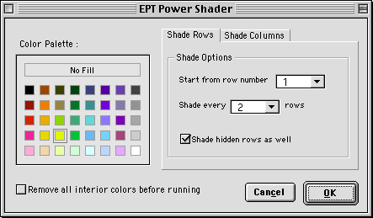

For example, you can easily shade every two rows in your spreadsheet with a yellow color. (Just fill in the form as the one shown above.)
Besides, with EPT Shader, while shading the rows/columns, all the hidden rows/columns will be taken care of intelligently. You can choose to (or not to) include the hidden rows/columns in EPT’s consideration during the shading process.

5. EPT Special Selections

EPT provides a set of advanced selection tools which ease the selection of special ranges of cells and report detailed information about areas of cells. Such functions include :

Function name | Description
Select Current Region | Expand the selection to include all the cells in the current data area.
Select Used Area | Select the (real) used cells in the current selection area or in the current worksheet.
Selection Info... | Through a dialog box, reports detailed range information on the current selection area(s). For example, info on constant range and formula range. You may also call EPT’s word count function from this dialog box. (refer to EPT Word Count)
Expand Selection | (pls. refer to 3D formatting)
Contract Selection | (pls. refer to 3D formatting)

6. EPT Word Play

EPT has the most powerful and sophisticated word/text manipulation tools among all the shareware add-ins available in the market. These “word play” functions form the core part of EPT. They were specially built, not only to “manipulate text”, but also to handle exceptionally large data files speedily and accurately without errors, while keeping Excel in a stable and responsive state.

The current version of EPT 3 provides the following “Word Play” functions :

- EPT Split-Up Words Wizard
- EPT Combine Words
- EPT Extract Initials
- EPT Change Case
- EPT Power Append
- EPT Word Count
- Randomize Order
- EPT Random Numbers
- Units Conversion
- Matrix Transform
- Negative Reposition
- Super Number->Text Wizard

Each of these functions will be explained in the following sections.

6.1 EPT Split-Up Words Wizard

What does it do?

Basically, EPT Split-Up Words Wizard was designed to split up words in individual cells (, each of which might contain more than one word, ) and put each word into individual cells.

A common application could be the splitting-up of first name, middle name and last name in a list of full names. (And in fact, this function was specially built for such tasks.)

The wizard...

EPT Split-Up Words Wizard is a 2-step wizard which guides you through the splitting-up of words in your list of data. Just choose the appropriate options in each of the steps, and the wizard will do the splitting for you.

In Step 1 of the Split-Up Words Wizard, you can decide whether you are splitting “General text data which may or may not be names” or “Names”. (The reason for deciding this is that EPT provides special facilities specially designed for splitting up names.)

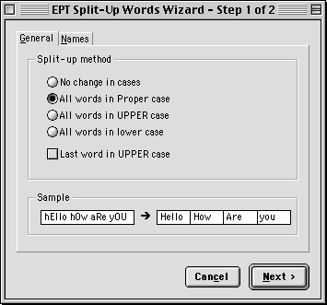

If you chose “General” in the first step, you’ll see the following dialog box. You can decide how you would like EPT to handle the upper and lower cases of the text output. In the “Sample” area in the bottom, you can have an idea how your choice would affect the text output.

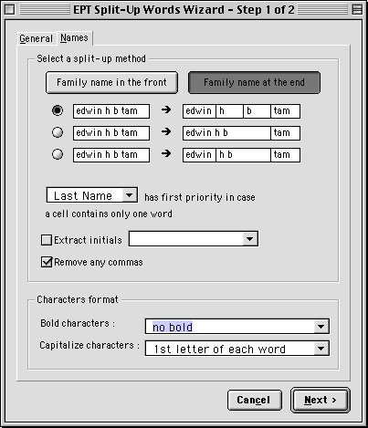

On the other hand, if you chose “Names” in the first step, you see a different dialog box like the one shown on the right. You’ll be presented options which are specific for the splitting up of names.

Unlike normal text data, names often have “First Name”, “Middle Name”, and “Last Name”. A “Middle Name” may sometimes contain more than one string (or word), or there may be totally no “Middle Name” at all in a name. Therefore, just extracting the first and/or last names from a large list of names could cause a headache. There may simply be too many combinations of variations.

However, EPT simplifies this complicated task for you. Just choose the options which you find the most appropriate, and click “Next>“ to proceed to the final step!

The final step is simple. Just choose where you want EPT to put the output text. Click “Finish” and sit back, and let EPT process the names for you!

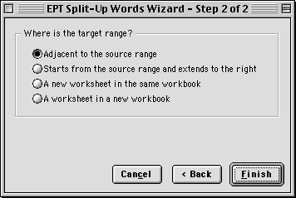

Like other EPT Word Play functions, EPT Split-Up Words Wizard was designed to process huge data files. It has been thoroughly tested for its practical usability on huge real-life data files.

When processing a huge lists of data, EPT will inform you of the progress through the status bar at the bottom of the screen. Besides, EPT makes sure that your computer is not “frozen” while processing and you can interrupt EPT’s operation at any time by pressing the Esc key on your keyboard. After the interruption, you’ll be asked whether you want EPT to continue processing or to abort. Such nice, advanced, and stable facilities are definitely only available in EPT!!

6.2 EPT Combine Words

What does it do?

EPT Combine Words was designed to combine words (or data) in multiple columns into a single column. It is a 2-Step wizard, which guides you through the combining of columns.

In Step 1 of the wizard, you can decide how you want EPT to combine the cells in the columns you’ve selected. You can choose to combine in different orders, and with/without space inserted between strings.

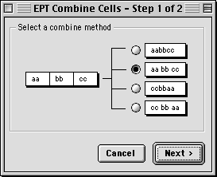

Step 2 of the Combine Words Wizard is exactly the same as the last step of the EPT Split Up Words Wizard. (Refer to section 6.1) Such consistencies in the wizards make sure EPT functions are easy to use and minimize the time required to accustom to different functions.

6.3 EPT Extract Initials

What does it do?

EPT Extract Initials is a tool for converting text data into initials. A common application can be the conversion of names into initials.

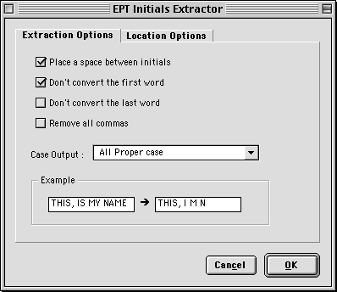

The tool is pretty flexible. There are several user-define options, and it can do the case change at the same time.

6.4 EPT Change Case

What does it do?

EPT Change Case is a flexible tool for manipulating the “cases” of text in the selection area(s). Besides the basic upper/lower/proper cases options, EPT also provides several other customized options so that you can have better control over the cases of text in the cells.

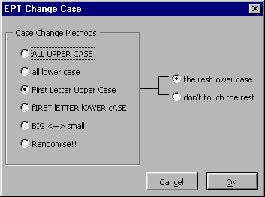

6.5 EPT Power Append

What does it do?

EPT Power Append is a tool for appending (adding) text (or whatever characters you can key in) into the selected cells.

You can choose to -
- insert the characters before and/or after the content of each cell; or
- specify only when a cell contains a certain text string EPT inserts the characters before and/or after the specified string. (You can further define whether to append only once or every time the specified string is found in a cell.)

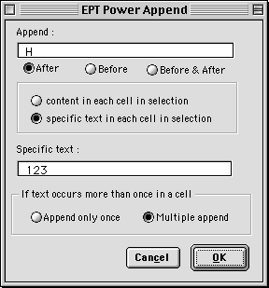

6.6 EPT Word Count

What does it do?

EPT Word Count is probably the best word count tool for Excel. It not only “counts the number of words” in the cells, but also provides important and useful word count statistics of a spreadsheet.

Below shows a sample EPT Word Count report. The interface was designed to be simple to understand.

With the option buttons on the left-hand side, you can choose to view the statistics for 1) the whole selection, 2) the constant range only, and 3) the formula range only.

“EPT Word Count” is also linked to “EPT Selection Info”. Therefore, while you’re gathering range information of the selections/worksheet, you can choose to have a detailed word count report as well. (Please refer to section 4 for more information on “EPT Selection Info”.)

6.7 Randomize Order

What does it do?

The function “Randomize Order” re-organizes the contents of the selected cells in a randomized order.

6.8 EPT Random Numbers

What does it do?

“EPT Random Numbers” in fact contains (a set of) advanced random number generators. (Obviously, this function is for generating random numbers.)

“EPT Random Numbers” function is divided into two main modes : Normal , and Advanced. Each of these modes are in fact different wizards which guides you through the steps for generating random numbers you required.

Normal mode -

The “normal” mode of EPT Random Numbers is a 2-step wizard. It was designed for quick generation of random numbers, which do not necessarily have to follow any particular distribution. Or, you can say that this mode is for less advanced users who do not require strict controls over the numbers drawn.

However, the normal mode still provides users with a wide range of basic controls over the random numbers. For example, you can decide to draw integers, whole numbers, real numbers, odd/even numbers, etc. Also, you can define how EPT handles upper and lower bounds. You can draw multiple sets of numbers at once, decide whether the numbers drawn must be different, and even choose to sort the output numbers.

Advanced mode -

The “advanced” mode of EPT Random Numbers is a 3-step wizard. It was designed for users who need to have higher level of control over the random numbers. EPT has several built-in advanced random number generators for this purpose. These generators are capable of generating numbers which are perfect for, for instance, computer simulation purposes.

6.9 Units Conversion

What does it do?

EPT Units Conversion is a very flexible tool for converting numbers from one measurement system to another. For example, it can translate a table of distances in miles to a table of distances in kilometers.

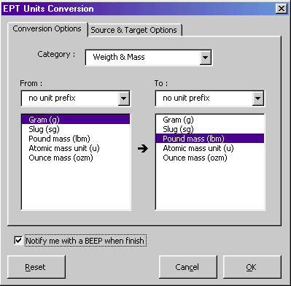

EPT Units Conversion translates the following units :

Weight and mass |  | Distance
Gram "g"  Slug "sg"  Pound mass (avoirdupois) "lbm"  U (atomic mass unit) "u"  Ounce mass (avoirdupois) "ozm" |  | Meter "m"  Statute mile "mi"  Nautical mile "Nmi"  Inch "in"  Foot "ft"  Yard "yd"  Angstrom "ang"  Pica (1/72 in.) "Pica"
Time |  | Pressure
Year "yr"  Day "day"  Hour "hr"  Minute "mn"  Second "sec" |  | Pascal "Pa"  Atmosphere "atm"  mm of Mercury "mmHg"  Bar “bar”

Force |  | Energy
Newton "N"  Dyne "dyn"  Pound force "lbf" |  | Joule "J"  Erg "e"  Thermodynamic calorie "c"  IT calorie "cal"  Electron volt "eV"  Horsepower-hour "HPh"  Watt-hour "Wh"  Foot-pound "flb"  BTU "BTU"
Power |  | Magnetism
Horsepower "HP"  Watt "W" |  | Tesla "T"  Gauss "ga"
Temperature |  | Liquid measure
Degree Celsius "C"  Degree Fahrenheit "F"  Degree Kelvin "K" |  | Teaspoon "tsp"  Tablespoon "tbs"  Fluid ounce "oz"  Cup "cup"  Pint "pt"  Quart "qt"  Gallon "gal"  Liter "l"

Besides, EPT Units Conversion supports a wide range of abbreviated unit prefixes :

Prefix Multiplier Abbreviation

exa 1E+18 "E"
peta 1E+15 "P"
tera 1E+12 "T"
giga 1E+09 "G"
mega 1E+06 "M"
kilo 1E+03 "k"
hecto 1E+02 "h"
dekao 1E+01 "e"
deci 1E-01 "d"
centi 1E-02 "c"
milli 1E-03 "m"
micro 1E-06 "u"
nano 1E-09 "n"
pico 1E-12 "p"
femto 1E-15 "f"
atto 1E-18 "a"

6.10 Matrix Transform

What does it do?

EPT Matrix Transform is a tool specially designed for the “transformation” (or manipulation) of rectangular “blocks” of data.

Those who are familiar with graphics software such as Macromedia Freehand and Corel Draw should have already been familiar with the “transform” of graphics, in which you can flip or rotate graphic items easily using a toolbox. There was also where the ideas of EPT Matrix Transform came from.

“Why tables typed in Excel cannot be rotated or flipped as easily as in graphics packages?” I believe spreadsheet users with considerable curiosity should have thought of this question while using Excel. (This is in fact a dream function of mine for many years!)

Now, EPT 3 provides you with an advanced solution to the above question. This solution is also one which has been fully adapted to the spreadsheet environment. It does more than simple rotations and flips. Basically, you can do the following matrix transformations :

- Rotate (90°, 180°, 270°)
- Calculations -
- Cofactor matrix
- Adjoint matrix
- Inverse matrix
- Transpose
- Self multiplication (to the n-th power)
- Multiplication by a constant
- Division by a constant
- Flip (horizontal, vertical)

It must be emphasized that rotations and flips are NOT LIMITED TO CONSTANTS. EPT would intelligently take all the formulas, formats, and even notes into consideration when performing the transformations, and allows you to decide which one(s) of those you want to include in the transformation. This makes EPT Matrix Transform more versatile to use.

To “transform” a range, just select the range to be transformed, and run EPT Matrix Transform. The range selected MUST be a single rectangular range. Whether it should be a “square” range (with equal number of rows and columns) depends on the transformation function you want to perform.

D E F G H
EPT Power –
The original table (Top, D8:H12), after being rotated by 90 degrees counter-clockwise, all formats have been retained, and all formulas have been re-organized. (Bottom, D17:H21).

The 3-step transformation wizard -

EPT Matrix Transform is a 3-step wizard, which guides you through the transformation/manipulation of (rectangular) blocks of cells.

Step 1 - In this first step, you decide the type of transformation you want to perform. (Rotate, Calculate, or Flip)
Step 2 - You will see the Step 2 dialog box only if you chose “Rotate” or “Flip” in Step 1. In this step, you decide whether to rotate/flip the values/formulas/format/notes in the selected range.
Step 3 - In this final step, you’re prompted for the addresses of the “source range” and the “target range”.
“Source Range” is the range which contains the block of cells you want to transform.
“Target Range” is the location you want EPT to put the transformation output.
For the ease of use, you don’t necessarily have to define a target range with exact dimensions. You just need to decide the top-left cell and EPT will correct the output dimensions for you.

6.11 Negative Reposition

What does it do?

Ever met data files exported from other database software, with all the negative signs of the negative data put in the wrong positions, that caused problems in your Excel spreadsheet calculations?

EPT Negative Reposition is a tool for the reposition of negative signs from the front/end of a cell to the end/front of the cell. The content of the cell is not limited to number, but could also be text.

The tool is versatile as well as easy to use. It allows different settings for the handling of numeric data and text data, so that you can have better control over the output.

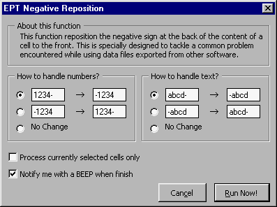

6.12 EPT Super Number->Text

A function for translating numeric expressions into English language equivalents, with built-in intelligence which is capable of handling a wide range of numeric inputs, and which can handle English grammar and currency-specific words correctly, and, of course, very easy to use and requires a minimum amount of user input, have long been a dream of a lot of spreadsheet users and solution developers.

EPT Super Number->Text is your ultimate solution. It is the result of more than 2 years of continuous research, programming, testing and fine-tuning. It is an unrivalled number to English translation tool for the Microsoft Excel spreadsheet environment. It is absolutely the best ever developed tool of its type for the spreadsheet.

What does it do?

EPT Super Number->Text translates numbers into English language equivalents.

The components -

The EPT Number->Text tool is divided into two main components :
- The EPT Super Number->Text Wizard
- The EPTNUM2TXT worksheet function

(1) The EPT Number->Text Wizard

You can access the “EPT Super Number->Text” Wizard from the EPT menu, under the “EPT Word Play” submenu.

After initializing the function, you’ll see a well-organized interface, in which you can decide how you want the numbers to be translated.

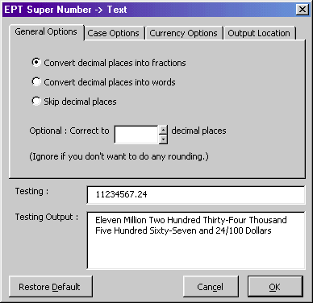

The options for controlling the translation output are systematically grouped into 4 categories :

- General Options - | For the control of the handling of decimal places in numbers
- Case Options - | For the control of upper, lower, or proper cases in the translation output.
- Currency Options - | For the assignment of currency-specific text strings to the translation output.
- Output Location - | For telling EPT where to put the translation output.

In addition to the powerful facilities, EPT Number->Text Wizard also provides you with a “testing area” in its interface, in which you can test input some numbers and have a rough idea about how the choices you made would affect the translation output.

The EPT Number->Text Wizard has the ability to “remember” all your previous settings and automatically restore them the next time you use the function.

(2) The EPTNUM2TXT worksheet function

In the full (registered) version of Edwin’s Power Tools, there is a new worksheet function EPTNUM2TXT. This worksheet function has been completely re-written and is substantially different from the one in EPT 3.0 and below.

Function of EPTNUM2TXT -

Translates a number into English Language text.

Limitations -
- Absolute value of the number input must be smaller than one thousand nonillion. (US English definition : 10³³) (i.e. -1E+33<x<1E+33)
- Under Excel 5 and 7, length of translation output must not exceed 255 characters, which is the maximum length a cell can accommodate. Under Excel 8 (Excel 97), length of translation output must not exceed 32,000 characters
- The language translation adopts the US English convention.

Syntax -

EPTNUM2TXT(number, frac, places, dollar_txt, cent_txt, output_case, smart_case)

number is the number to be translated into English. It can be either a positive or a negative number; with/without decimal places. It may also be in scientific format, e.g. 234E+17

frac is a number either 1, 2, or 3. It determines the way decimal places (, if any,) are being treated. Default value is 1. (Optional)

Set frac equals to | If decimal places exist
1 or omitted | Translated into a fraction. e.g. 0.27 = 27/100 ; 0.12345 = 12345/100000
2 | Translated into English words. e.g. 0.27 = zero point two seven
3 | Completely ignore any decimal places. e.g. 1.6 = one

place determines how many decimal places (,if any,) to which you want to round number. (Optional)

dollar_txt is the text string to be placed before the decimal places. (Optional) For example, when translating the number “123”,

dollar_txt | Translation output
“Dollar” | One-Hundred Twenty-Three Dollar
“Pound” | One-Hundred Twenty-Three Pound

cent_txt is the text string to be placed after the decimal places. (Optional)
For example, when translating the number “123.25”,

dollar_txt | cent_txt | Translation ouput
“Dollar” | “Cent” | One-Hundred Twenty-Three Dollar Twenty-Five Cent
“Pound” | “Pence” | One-Hundred Twenty-Three Pound Twenty-Five Pence

output_case is a number either 1, 2 or 3. It determines whether the output text string is in upper, lower, or proper case. Default value is 1. (Optional)

Set output_case equals to | Effect
1 or omitted | Output text in UPPER case
2 | Output text in lower case
3 | Output text in Proper case

smart_case is a Boolean value either TRUE or FALSE. It determines whether the word “AND” should always be in lower case. Default value is FALSE. (Optional)

Set smart_case equals to | Effect
TRUE | The word “and” always in lower case
FALSE or omitted | The word “and” follows the value of the variable output_case.

Remarks -

EPTNUM2TXT translation employs the following definitions :
- one billion = one thousand million = 1E+9
- one trillion = one thousand billion = 1E+12
- one quadrillion = one thousand trillion = 1E+15
- one quintillion = 1E+18
- one sextillion = 1E+21
- one septillion = 1E+24
- one octillion = 1E+27
- one nonillion = 1E+30

7. EPT Killers

EPT Killers is a new category of tools in EPT version 3. As implied in the name, it “kills” something in your spreadsheets.

The current version of EPT 3 provides the following “EPT Killer” functions :

- Remove Irregular Spacings
- Remove All Spaces
- EPT Duplicated Rows Killer
- Empty Rows Killer
- Empty Sheets Killer
- Hyperlinks Killer

Each of these functions will be explained in the following sections.

7.1 Remove Irregular Spacing

What does it do?

Remove Irregular Spacing, as it is called, removes any “irregular” spacing from the content of the cells in the selection area(s). Basically, it does not allow for more than one space between every two words.

7.2 Remove All Space

What does it do?

Remove All Space removes any space from the cells in the selection area(s).

7.3 EPT Duplicated Rows Killer

What does it do?

This is a function specially designed to delete duplicated rows in your spreadsheets.

The Flexible Wizard

After loading the function, you’ll have to answer some questions about your data file(s) (or spreadsheets) to instruct EPT how you would want it to locate & delete the duplicated rows.

The “EPT Row Delete Wizard” provides mainly two row-delete strategies :
- Locate & Delete duplicated rows in one data range (and leave only unique rows). This strategy looks at 1 data range only.
- Compare & Delete. This strategy compares 2 ranges of data, and delete rows from one that already appeared in the other.

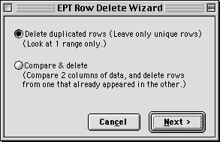

Strategy 1:

The first strategy is to scan only 1 data range, and delete duplicated rows.
There are 3 options for this strategy :
- single-column scan
- 2 columns scan (choose to match only 2 of the columns)
- all columns scan

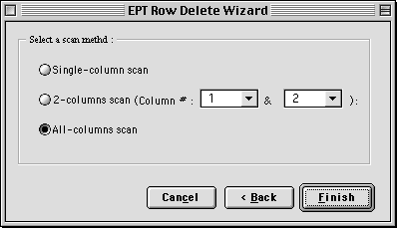

Strategy 2:

The 2nd strategy is to scan 2 data ranges (source and target), and delete duplicated rows from one (target) that already appeared in the other (source).

(See the figure below.) You have to input the addresses of the source range and the target range into the form. But you don’t need to type them yourself. You can enter the addresses by selecting the ranges with your mouse.

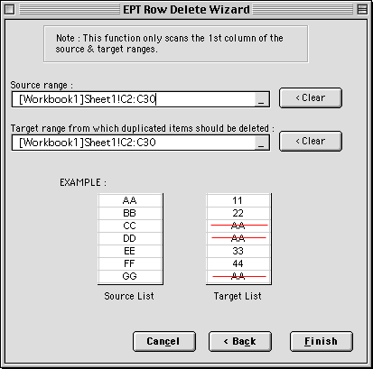

7.4 Kill Empty Sheets

This function deletes all empty worksheets in the current workbook.

(However, because there must be at least one sheet in any workbook, Delete Empty Sheets cannot delete an empty worksheet if that worksheet is the only sheet in the workbook.)

7.5 Hyperlinks Killer

Use this function to locate and “kill” (remove) hyperlinks defined in the current workbook.

8. EPT Workbooks Management

EPT has a set of very powerful and unique workbooks management tools.

These tools are not simply “the application of VBA in the automation of MS Excel objects”. They’re the result of continuous observation and research on how spreadsheet users navigate the spreadsheet environment.

There have never been spreadsheet management tools as useful and as practical as the ones in EPT. This was because this type of tools for the spreadsheet is among the most difficult ones to develop. The tasks they perform are difficult to be summarized logically. The large number of combinations and possibilities (and user preferences) also make the planning stage difficult. Besides, the development requires thorough knowledge in the spreadsheet environment and the behavior of spreadsheet users, which are usually what programmers lack.

EPT Workbooks Management tools use the highest-level Excel VBA programming to automate complicated, or sometimes laborious, everyday workbooks management tasks, so that you can save more of your time concentrating on your spreadsheet analysis and thus improve your efficiency.

The workbooks management tools in EPT 3 includes :

 | Description
- Revert to Saved (New) | To revert to the last saved version of the current workbook.
- EPT Navigator | The “Spreadsheet Explorer” for Excel.
- EPT Sheets Sorter | Sorts your spreadsheets in order.
- EPT Zoom Control | Systematically controls the zoom ratios of all visible windows.
- Visibility -  - Power Hide  - EPT Anti-Stealth  - Visibility Check | - Set the visibility of your spreadsheet(s) to xlVeryHidden.  - A more powerful unhide command which unhides any hidden sheets.  - Gives you a summary of the visibility status of all sheets in the current workbook.
- EPT Duplicate Sheets | Duplicates all selected (or grouped) sheets.
- Print Multiple Sheets (New) | Print multiple worksheets at once!
- Toggle Window Options | Quickly toggles the TRUE/FALSE properties of the window options of the currently actived window.

8.1 Revert to Saved

This is a newly introduced EPT workbook management function. Use it to revert to the last saved version of the current workbook.

For example, you just opened a workbook to edit. After making a lot of changes, you decided that you don’t want to keep the changes and want to re-open the previously saved version of the workbook. Normally, you need to close the workbook without save, then open it again. Now, with “Revert to Saved”, you can immediately have the last saved version opened for you.

8.2 EPT Navigator

EPT Navigator is the File Explorer for your spreadsheets.

In EPT 3, EPT Navigator provides you with 4 different views to look at your spreadsheet files. Each of these four views lets you look at your files from a different perspective. While the structures of the files are systematically visualized, you can manage the files better and more efficiently.

 | Description
- Sheets View | You can see the structure of one workbook file at once. Sheets of different types are listed separately.
- Workbooks View | You can see a full list of all opened workbook files.
- Dual-Workbook View | You can see the lists of sheets in two opened files at once. This is useful when you want to see more workbooks and the sheet types are not important to you. This view also facilitates the interchange of sheets between two workbooks.
- Windows View | You can see a list of all currently visible windows.

8.3 EPT Sheets Sorter

What does it do?

EPT Sheets Sorter sorts the sheets in your workbooks in order, base on the criteria you defined. This function was designed to be so flexible and powerful that you can sort your spreadsheets in almost any way you desire.

Besides, because of the special nature of this function, EPT Sheets Sorter was designed to be Year 2000 compliant. This further ensures the successful sorting of your spreadsheets
(, as well as your confidence in using this function).

The 2-Level Sheets Sorter

EPT Sheets Sorter provides two levels of sorting: Normal (for novice users) and Advanced (for advanced users). “Normal” provides basic sorting facilities which are more straight-forward. “Advanced” provides the most powerful spreadsheet sorting facilities which are highly customizable.

To switch between the “Normal” and “Advanced” sheets sorter, click onto the buttons labeled “Normal” or “Advanced” on the bottom-left corner of the EPT Sheets Sorter dialog boxes.

“Normal” Sorting

“Normal” sorting lets you sort the sheets in the activeworkbook in any of the following orders:

“Normal” sorting criteria | Remark
- Ascending (alphabetical) order
- Descending (alphabetical) order
- Length of tab names (ascending)
- Length of tab names (descending)
- Reverse order | Reverse the order of the sheets  (i.e. 1,2,3,4 to 4,3,2,1)
- Random order | Organize the sheets in the activeworkbook in a randomized order

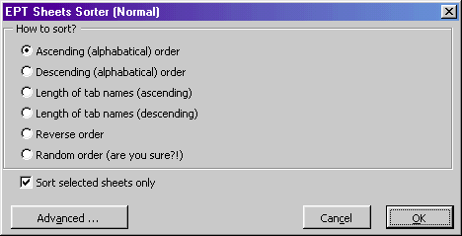

On the “Normal” Sheets Sorter dialog box, there is a checkbox labeled “Sort selected sheets only”. Checking this checkbox would cause EPT Sheets Sorter to sort only the currently selected sheets. (Or in Excel 8 terminology, the currently “grouped” sheets.)

“Advanced” Sorting

In “Advanced” sorting, you can sort your sheets base on advanced criteria. These criteria are grouped into three categories : Basic, Custom Lists, and Date Formats.

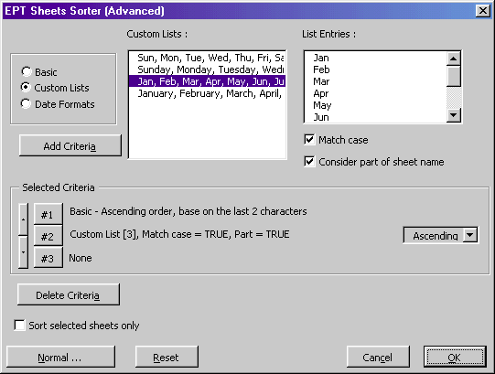

 | Descriptions
- Basic | - Ascending (alphabetical) order  - Descending (alphabetical) order  - Length of tab names (ascending)  - Length of tab names (descending)  - Sheet Types (*not available in “normal” sorting)  - Reverse order  - Random order  In “Advanced” sorting, the “sort by alphabetical order” is more flexible. It allows the consideration of only part of the sheet names. e.g. the last 2 characters, or the 2nd to 5th characters, etc.
- Custom Lists | EPT lets you sort your sheets by referring to the “custom lists” available in Excel. (Note 1)  EPT Sheets Sorter is directly linked to Excel’s “custom lists” function. It means you can expand its sorting power by expanding the library of custom lists.  Besides, while sorting by custom lists, you can also choose to have a case-sensitive sort based on a custom list, and/or you can ask EPT to consider only part of a sheet’s name while sorting. This is especially useful when you’re sorting by Month (e.g. Jan, Feb, Mar) while the sheet names contains the Year as well (e.g. Jan 98, Feb 98, Mar 98).
- Date Formats | This is a sorting method pinpointing the convention most spreadsheets are named -- by Date. However, this category only deals with dates with numbers, e.g. 8_8_98, but not 8 August 98. (The later could already be dealt with using a combination of criteria in other categories.)  Besides, while sorting the sheets by date, EPT would handle 2-character years well. E.g. it understands that year 00 is year 2000.  By default, EPT Sheets Sorter considers any years smaller or equals to 15 to be in the 21st century. But you can change this setting easily by using a dialog box.  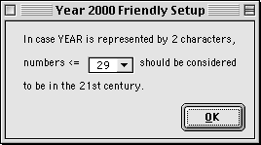

(Note 1) For more information about Excel custom lists, please refer to Excel’s on-line help.

Like “Normal” sorting, on the “Advanced” Sheets Sorter dialog box, there is a checkbox labeled “Sort selected sheets only”. Checking this checkbox would cause EPT Sheets Sorter to sort only the currently selected sheets. (Or in Excel terminology, the currently “grouped” sheets.)

8.4 EPT Zoom Control

What does it do?

EPT Zoom Control is a simple utility for the easy control of zoom ratios of visible windows. It also allows the assignment of zoom ratios to multiple windows at once. (Just hold the Ctrl key while making your selections with your mouse.)

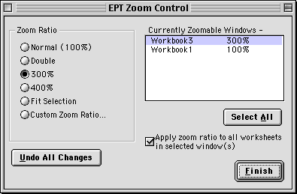

8.5 EPT Duplicate Sheets

What does it do?

With EPT Duplicate Sheets, you can quickly duplicate all selected (or grouped) sheets in the currently actived workbook.

To duplicate sheets, follow the steps below:

- In the currently actived workbook, select the sheet(s) you want to duplicate. You can select more than one sheet. To select multiple sheets, hold the Ctrl key while clicking on the sheet tabs (i.e. the small tabs which contain the names of the sheets at the bottom of the screen).
- Run EPT Duplicate Sheets.

Tip : After selecting the sheets you want to duplicate, you can quickly access the EPT Duplicate Sheets function by right-clicking on any of the sheet tabs. A short-cut menu will pop up, with the item “EPT Duplicate Sheets” for you to choose.
(Actually, you can access almost all EPT functions by using short-cut menus.)

8.6 Print Multiple Sheets

What does it do?

Provides a convenient and user-friendly interface for printing multiple sheets in your workbooks at once.

After loading the “Print Multiple Sheets” function, you’ll see a window which shows you a list of your currently opened workbooks (the dropdown list on top) and the worksheets in the workbooks.

Choose a workbook from the dropdown list, and check the sheets you want to print, and press the Print button to print.

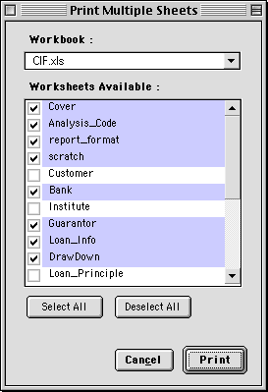

8.6 Toggle Window Options

EPT provides a set of convenient functions for quick toggle of the True/False (or Visible/Invisible) values of several window properties.

 | Descriptions
- Toggle Gridlines | Toggles the visibility of the gridlines in the active window.
- Toggle Headings | Toggles the visibility of the column and row headings in the active window.
- Toggle Horizontal Scroll Bar | Toggles the visibility of the horizontal scroll bar in the active window.
- Toggle Vertical Scroll Bar | Toggles the visibility of the vertical scroll bar in the active window.
- Toggle Workbook Tabs | Toggles the visibility of the workbook tabs in the active window.
- All On | Turns all (1) to (5) ON.
- All Off | Turns all (1) to (5) OFF.

9. EPT Global Assignment

EPT Global Assignment is a new series of tools introduced in EPT version 3. The first tool in this series to introduce is Global Assign Page Setup.

Global Assign Page Setup

What does it do?

This function assigns the Page Setup properties of the currently worksheet to specific target worksheets. For example, you can assign the margins properties globally to all worksheets in a workbook, etc.

The function is simple and straight forward, but very useful and powerful. It is definitely a dream function of many Excel users for ages. Now, you finally see this in EPT 3.

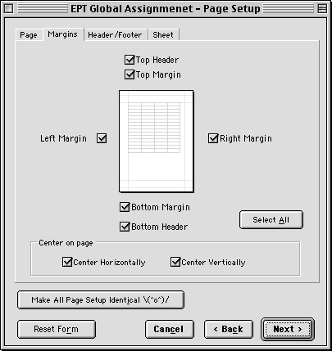

10. EPT (Perpetual) Calendar

What does it do?

This is a function newly introduced in EPT 3. This is a “Perpetual Calendar”. You can quickly view the monthly calendar of a specific month within a specific year. Also, you can export monthly calendars to your workbook.

The figure below shows the EPT Calendar screen. (It is now showing the December 2003 monthly calendar.)

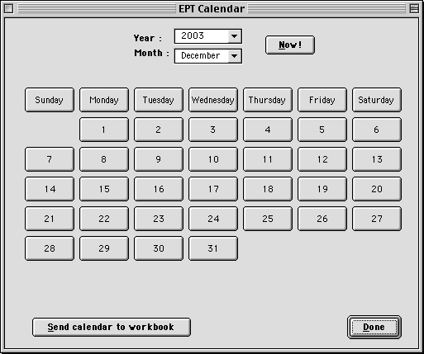

To export calendars to worksheets, press the “Send calendar to workbook” button, and you’ll see another form (see below) for you specify which months you want.

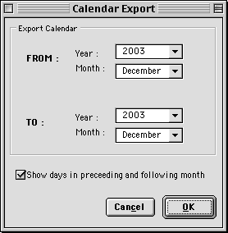

11. Miscellaneous Tools

Copy Column Widths

An EPT function for copying the column widths of some columns to another specified destination.
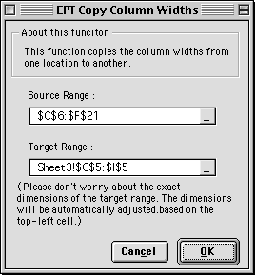

You need to define the “source” and the “target” areas. The “source” is from where the columns widths should be copied; “target” is the destination. The target range can be on any range on any worksheet in any workbook. You can specify it with your mouse. (Use your mouse to locate the target area.)

When specifying the “target” area, you don’t have to worry about the exact dimensions of the specified range. EPT will automatically adjust (resize) that for you during run-time, based on the top-left cell of your specified range.

Copy Row Heights

A function similar to “Copy Column Widths”. But this copies the row heights instead. (Refer to the section above.)

Export Chart As Graphic
(EPT for Excel 97 for Windows & EPT for Excel 98 for Power Mac only)

With EPT, you can easily “Export” (or “Save”) your charts as any of the following graphics formats:

- JPEG
- GIF
- PNG

To export a chart as graphic,
- Right-click the chart you want to export as graphic.
- Choose “Export Chart As Graphic...” on the short-cut menu.
- In the dialog box that pops up, assign the file name, and choose the format you want to save the chart as.
- Press OK.

(In EPT for Excel 98 for the Power Mac, all exported charts would be placed on the Desktop of the Finder.)

12. EPT Help

EPT 3 has a new menu item group called “EPT Help” (can be found under the EPT menu). It is for easy access of EPT documentation and on-line EPT resources.

12.1 EPT On-Line Help

EPT 3 comes with a set of HTML on-line documentation. Choose this function to access it. (You need a web browser to read it.)

12.2 EPT User Manual

Access the MS Word version of the EPT User Manual.

12.3 EPT Worksheet Function Reference

Access the MS Word version of the EPT Worksheet Function Reference.

12.4 EPT Web Site

Access the MS Word version of the EPT Worksheet Function Reference.

12.5 EPT On-Line Version Check *

“EPT On-line Version Check” is a function which uses your existing Internet connection to automatically checks for newer versions of EPT on the official EPT web site.

In case a newer version is located on the server, you’ll be notified with a message like the one shown below. Click YES to be diverted to the EPT official download web page. (Click NO to abort.)

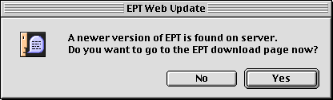

13. Frequent Asked Questions

Q: What will I receive after registering?

A: After your registration has been successfully processed, you will receive :
- a registration confirmation from the author via e-mail. The e-mail will contain your unique set of “UserName”, “Address” and “Serial Number”, with which you can unlock EPT’s full functionality.
- Full access to ALL versions of EPT. (PC & Mac)
- Free, unlimited technical support via internet e-mail.
- Free upgrades to all future versions of the EPT shareware, including all major and minor upgrades.

Q: When I register, do you send me a password to "unlock" the other features?

A: YES. EPT 3 is far more advanced than any Excel add-ins in terms of registration. You change the demo into a full version by inputting your UserName, Address and a unique serial number, which will be sent to you shortly after registration.
Therefore, when an update is released, you can immediately download the new version and enjoy the latest EPT features. You don’t have to wait until I remember you and send you the updates by mail.

Q: After inputting my UserName, Address and Serial Number, EPT reported that my serial number was invalid. What’s happened?

A: Try inputting all the three carefully. Your input must be identical to the information shown in the e-mail confirmation, including all spacing, line feeds, and upper & lower cases.

However, if you’ve already input everything correctly and still couldn’t unlock EPT, you can try unloading EPT, completely removing EPT from your system, reinstall it, and input the serial number again. This is a rare case. This is not a problem caused by EPT itself but very likely by Excel.

Q: Do I have to pay again on the release of an EPT upgrade?

A: NO. All registered users are entitled to all major and minor EPT upgrades free of charge. So, please do not pay again. On the release of an EPT upgrade, just download it from my web site. Your registration code (serial number) can unlock all current and future versions of EPT.

Q: What language was EPT written in?

A: Edwin’s Power Tools (EPT) was written 100% in VBA, Microsoft Office’s built-in programming language for automation of the Office suite.

Q: My company uses both PC and Mac. Can I use EPT on both platforms so that our systems can have better consistencies?

A: Yes! There are PC and Mac versions of EPT. (Please refer to section 1.3 of this manual.) Each version was written exclusively on the particular version of Excel and the platform it was built for. It means EPT for Excel 97 for PC was developed in Excel 97 for PC; EPT for Excel 98 for Mac was developed on Excel 98 for Mac, etc. Although all versions of EPT look and feel the same, they’re separately developed and were programmed/tailor-made to take advantage of different platforms and versions of Excel. They are very different internally.

Therefore, you can expect the best performance of EPT on both the PC and Mac. This also makes EPT unique among all the Excel shareware add-ins.

Q: Do you sell the source code of EPT?

A: No. The source code of EPT is not for sale.

Q: What do I do if I discovered a bug in EPT?

A: First, visit the EPT official web site, and check to see whether you’re using the latest version of EPT. If you’re not sure, just download the newest file from the EPT web site. It is possible that the problem you discovered has already been fixed.
Secondly, send an e-mail to the author at eptools@netvigator.com, and describe the problem and the steps required to reproduce it (if possible). Once the problem has been confirmed, it will be fixed an update will be released.

Q: What should I do if I want to distribute EPT?

A: EPT is a shareware, which you can distribute freely to anybody to evaluate.
All individuals and magazines can distribute EPT without prior written authorization from the author. However, please, whenever possible, distribute the newest update of EPT.
Any publishers who want to include EPT in CD-ROMs attached to books, or mention about EPT in books must have prior authorization from the author.
However, distribution of a registered copy is prohibited. You must unregister it before distributing it. (Also refer to Section 1.8 “Unregistering & Distributing EPT”.)

Q: I am currently using several other 3rd-party Excel add-ins. Can I still use EPT without causing any conflict?

A: Yes. EPT should always operate very well even in the existence of other 3rd-party add-ins, and it does not interfere the normal operation of any other add-ins. In case you experienced any conflict, it is very unlikely to be the problem with EPT.

